Types of Switches
# Source: Chatgpt (GPT‑5 Mini) at [12/18/2025]
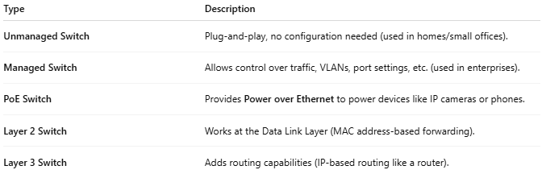

Type | Description
Unmanaged Switch | Plug-and-play, no configuration needed (used in homes/small offices).
Managed Switch | Allows control over traffic, VLANs, port settings, etc. (used in enterprises).
PoE Switch | Provides Power over Ethernet to power devices like IP cameras or phones.
Layer 2 Switch | Works at the Data Link Layer (MAC address-based forwarding).
Layer 3 Switch | Adds routing capabilities (IP-based routing like a router).

